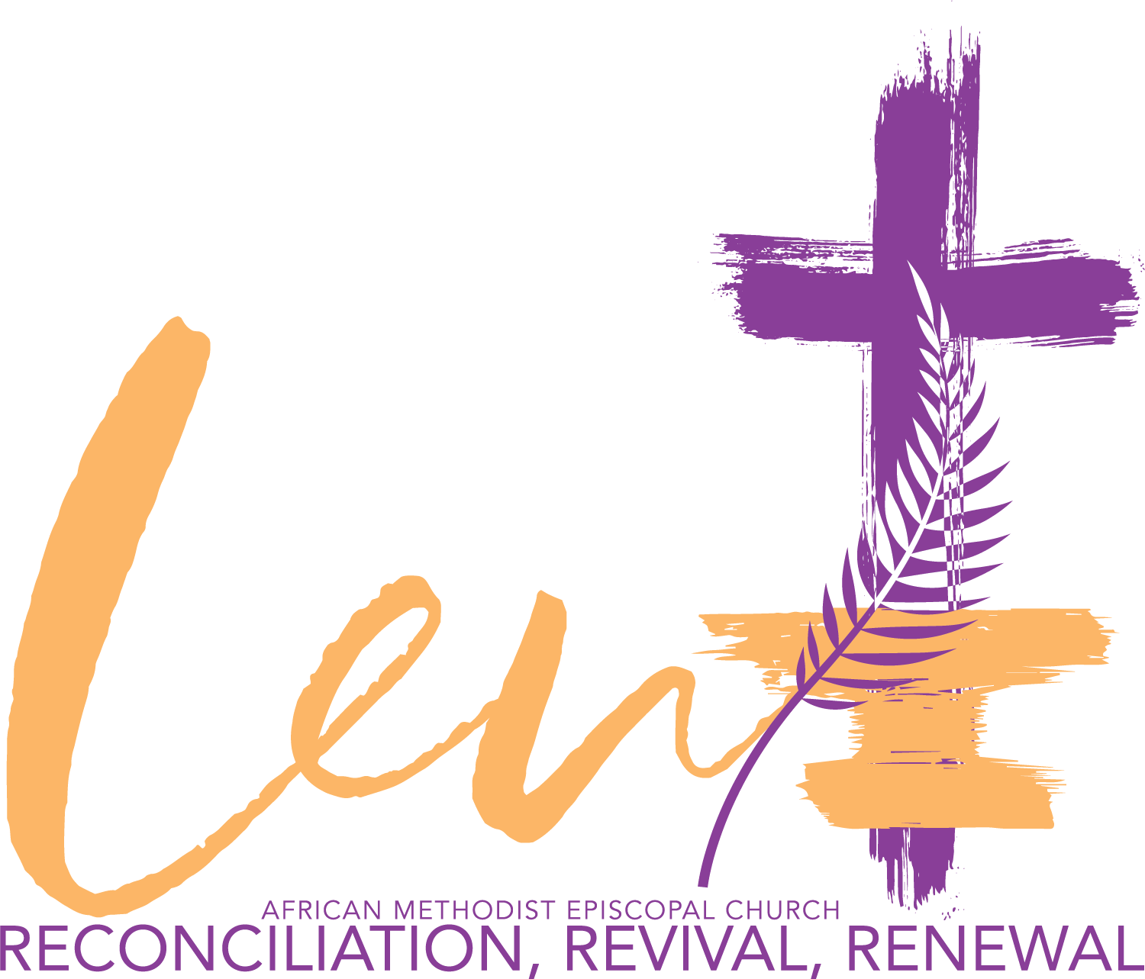

Greetings North Stelton family,

We praise God for another Lenten Season, beginning today, Ash Wednesday, a time of Reflection, Reconciliation, Revival and Renewal. As we consider the sacrifice of our Lord and how that impacts us personally, we ask that you join us in the following:

- Set aside time each day for a moment of prayer and scripture. We have included a link to a daily devotional guide from TODAY, a guide that Pastor Myra and I use regularly: 2022 Lenten Devotional Guide

- Join us in a Sacrificial Fast each Wednesday from 6:00 am to 5:00 pm and by giving up something for the next 40 days.

- Join us each Wednesday at 7:00 pm for our Weekly Lenten Services.

- Find a way to be a blessing to someone else.

It is our prayer that together we will all grow closer to our Lord as we observe this wonderful season as a family.

May God bless you, as we grow in Him.

Pastor Eric and Pastor Myra

